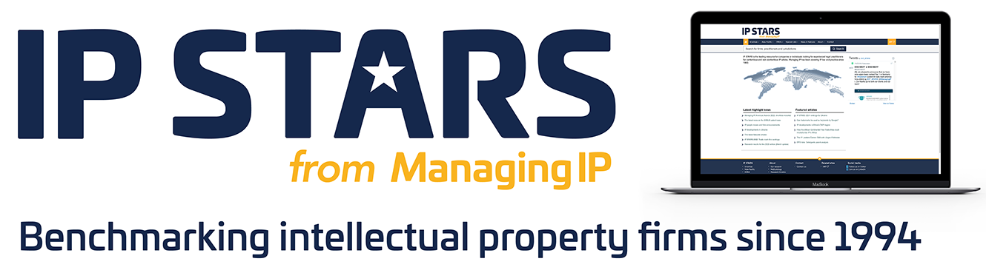

IN-HOUSE IP TEAMS & INDIVIDUALS OF THE YEAR
Company name
Contact name
Contact position
Email
Jurisdiction/Region

SUBMISSION DEADLINE: DECEMBER 1, 2022
PLEASE NOTE:
- Please use this form to make your in-house team nominations and/or to nominate individuals for the General Counsel or in-house Rising Star IP awards.
- Our in-house awards are presented by region: Americas, Asia-Pacific and EMEA. The location or jurisdiction of the in-house team or individual will determine which region the nominee is eligible for, but you can simply write the region you would like to be considered in the field above.
- Categories are listed within each section. You may enter as many or as few categories and/or nominees as you like.
- All submitted information must be uploaded via our submission portal.
- Awards are based on work or projects led by the team/individual in 2022. The Judging Panel will consider, among other things:
  - Cases, deals, or projects that have been transformative for the company or reflect unprecedented cross-departmental collaboration within the company
  - Innovative or exceptionally complex transactions and cases that impact the industry at large
  - Transformation within the legal team that enables it to actively shape the company’s strategy and performance
  - Impactful representation within industry associations, in influencing IP policy and in thought leadership
- For individual awards you may also attach a CV.

Please mark all confidential information in RED. Any information not denoted as confidential will be treated as publishable

IN-HOUSE IP TEAM OF THE YEAR

CATEGORY (indicate as appropriate):
Copy and paste this page for each new team.
In-house Copyright Team of the Year | ☐
In-house Patent Team of the Year | ☐
In-house Trademark Team of the Year | ☐
In-house Design Team of the Year | ☐
OVERVIEW
Team leader and job title:
Size and structure of in-house IP team (this is not used for judging awards):
IP right and sector strengths:
IP filing and dispute statistics:
Reason for putting the team forward (max 300 words):

WORK HIGHLIGHTS
Provide impactful / transformational work from 2022 that exemplify the IP legal team’s contributions to the company.

Copy and paste this table structure for each example – the awards will focus on quality, not quantity of the submissions. We recommend not more than three examples.
Project or work:

Relevant jurisdiction or region:
Date completed / key milestone:

Value (if applicable):

Description of the project or work and why it was complex, impactful, and/or innovative:

Key external legal counsel/law firm involved (if applicable)

IP AND BUSINESS STRATEGY
Provide examples from 2022 that exemplify the IP legal team’s contributions to the company, including:
- Business engagement and growth
- Inclusion of new technologies within the company
- Growth and development of the team
- Engagement with the CEO
- Engagement with individual executives and the board (executive) as a whole
- Cross-functional collaboration
- Successful IP strategy
- Diversity, equity, and inclusion policies the team assisted on and/or implemented

IN-HOUSE IP LEADER OF THE YEAR

CATEGORY (indicate as appropriate):
Copy and paste this page for each new nomination.
In-house Copyright Leader of the Year | ☐
In-house Patent Leader of the Year | ☐
In-house Trademark Leader of the Year | ☐
In-house Design Leader of the Year | ☐

OVERVIEW
Nominee name:

Position:

Email:

Reason for putting the nominee forward (max 300 words):

PROJECTS AND WORK HIGHLIGHTS
Provide details regarding the nominee’s achievements in business enabling, thought leadership, and examples of cases, deals, and/or projects in the IP space.
- For business enabling, please include the nominee’s key strategies, behaviours, and methods that exemplify their ability to bridge the gap between legal and the business, as well as examples of how the nominee has enabled business growth.
- For thought leadership please include and demonstrate the nominee’s impact and success in thought leadership activities (publications, speaking roles, panels, memberships in third party bodies).
Business enabling:

Thought leadership:

Testimonial from the CEO, CFO, COO, or other senior executives:

When requesting feedback, please ask the person in question to refer to specific projects as well as feedback on the team’s work overall

Copy and paste this table structure for each example – the awards will focus on quality, not quantity of the submissions.

Project or work:

Relevant jurisdiction or region:
Individual’s role and impact on the matter:
Date completed / key milestone:

Value (if applicable):

Description of the project or work and why it was complex, impactful, and/or innovative:

Key external legal counsel/law firm involved (if applicable)

IN-HOUSE IP RISING STAR
Rising Stars are those individuals who have been in practice for under fifteen years, be under forty years old, and acting in a leadership role and is not a General Counsel / Chief Legal Counsel / Head of Legal.

CATEGORY (indicate as appropriate):
Copy and paste this page for each new nomination.
In-house Copyright Rising Star | ☐
In-house Patent Rising Star | ☐
In-house Trademark Rising Star | ☐
In-house Design Rising Star

OVERVIEW
Provide details regarding the nominee’s achievements in business enabling, thought leadership, and examples of cases, deals, and/or projects in the IP space.
Nominee name:

Position:

Email:

Reason for putting the nominee forward (max 300 words):

IP ADVOCACY & INFLUENCE
- Please demonstrate the nominee’s impact and success in their professional field (roles in decision-making and the extent of those roles, examples of professional creativity and thought leadership)
Advocacy & Influence:

Testimonial from the Executive or nominee’s manager:

PROFESSIONAL ACCOMPLISHMENT
- Please detail examples of the nominee’s key recent IP legal work, business engagement, growth for the company, and cross-functional collaboration(s).
Copy and paste this table structure for each example – the awards will focus on quality, not quantity of the submissions.

Project or work:

Relevant jurisdiction or region:
Individual’s role and impact on the matter:
Date completed / key milestone:

Value (if applicable):

Description of the project or work and why it was complex, impactful, and/or innovative:

Key external legal counsel/law firm involved (if applicable)

